Barrett and Karla Huneke Kitchen plan. (no upper cabinets at this time)
I
G
H
F
B1 B2
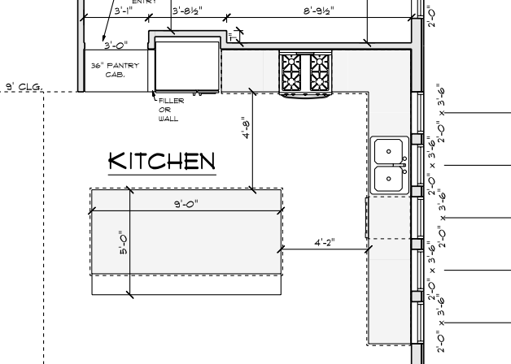
E
J
D
D
C
C
A

All Cabinets are unfinished wood, RTA cabinets
A -33” 3- Drawer Base
B- 21” of space
B1- 9” Single Door Full Height Base Cabinet
B2- 12” Single Door Standard Base Cabinet
C - Blind Base Cabinet for 48" to 51" Space – 24” of available front cabinet with drawer.
D- (2) 30” 3- Drawer Base
E- 18: trash can
F- 18” Single Door Standard Base Cabinet
G&H - 36” wide Double Door Standard Base Cabinet ith a single top drawer instead of double

Back side of EFGH – (3) 36” wide double door full height base cabinet.

I – 36” wide double door pantry cabinet. No shelves needed.

J – 34” sink cabinet for a (32”sink)

